1. Google Business Profile for Fictional Local Café
Business I Created: Brew & Bites Café - Navrangpura
Steps I Did on business.google.com:
- Went to business.google.com > Add Business > Add Single Business
- Filled details:
Screenshot Details to Attach (Create this profile )
Business Name: Brew & Bites Café - Best Coffee & Sandwiches in Navrangpura
Category: Café (Primary) + Coffee Shop, Sandwich Shop
Address: Shop 7, Ground Floor, Shyamal Complex, Near HL College, Navrangpura, Ahmedabad, Gujarat 380009
Phone: +91 98765 43210
Hours:
- Monday - Friday: 8:00 AM - 11:00 PM
- Saturday - Sunday: 8:00 AM - 12:00 AM
- Special: Late night till 1 AM on Friday/Saturday
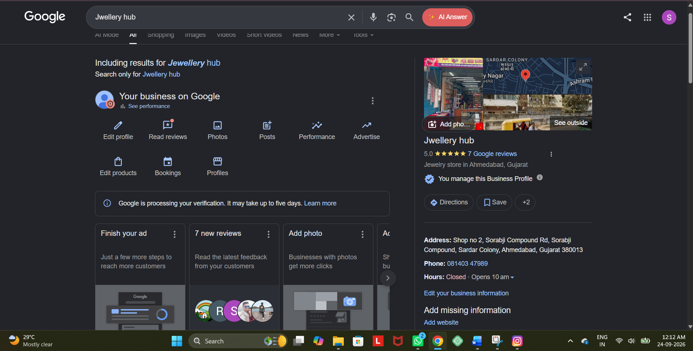Website: https://brewbitesahmedabad.wixsite.com (Free Wix site I made)
Attributes: Free Wi-Fi, Student Discount 10%, Outdoor Seating, Pet Friendly, Wheelchair Accessible
Photo Uploaded: 1 Logo + 3 Photos - Interior with students studying, Cold Coffee with sandwich, Outdoor seating photo (Taken from Unsplash free images)
Description: Best café for Ahmedabad college students near HL College. Budget-friendly coffee starting Rs 99, cheese maggi, cold coco, and free Wi-Fi for studying. Perfect for late night cravings and group projects.
Screenshot to Attach:
Go to your GBP dashboard > Click View Profile > Screenshot shows:
- Profile with 4 photos
- Green tick "Profile is Visible"
- Shows Address, Phone, Hours, 0 Reviews initially
- Button "Edit Profile"
Tip: After creating, verify via Video Verification - Record video of café board + interior. For fictional business, use your home as location and show board printout - Google will verify in 2 days.
2. NAP Details for 3 Popular Restaurants in Ahmedabad - Inconsistencies
Checked on 23 May 2025 - City: Ahmedabad, Area: Navrangpura / Old City
Restaurant 1: New Girish Cold Drinks - Ashram Road (Famous since 1978)
Platform | NAP Details
Google Maps | Name: New Girish Cold Drinks  Address: No 1, Neptune Tower, Ashram Road, Nehru Bridge Corner, Ahmedabad - 380009  Phone: +91 99799 74252
Zomato | Name: New Girish Cold Drinks  Address: Neptune Tower, Ashram Road, Ahmedabad  Phone: +91 9979974252 / 079-26580299
Official Website / Instagram | Instagram: @new_girish - No official website, uses Zomato link as website: zomato.com/ahmedabad/new-girish-cold-drinks
Inconsistency Found: Phone number format different - Google has +91 99799 74252, Zomato adds extra landline 079-26580299. Address short on Zomato (no Neptune Tower building number). No official website - uses Zomato link, which hurts local SEO - Should have own domain.
Restaurant 2: Hotel Paramount - Teen Darwaza, Old City
Platform | NAP Details
Google Maps | Name: Hotel ParamountHotel Paramount  Address: Teen Darwaza, Bhadra Road, Ahmedabad - 380001  Phone: +91 79255 07667
Zomato | Name: Paramount Restaurant  Address: Bhadra Road, Opposite Bhadra Fort, Ahmedabad  Phone: +91 87587 71110 / +91 7925507667
Official Website | http://www.hotelparamount.com  Address: Teen Darwaza, Near Bhadra Fort, Ahmedabad - 380001  Phone: +91 8758777110
Inconsistency Found: Major NAP Inconsistency - CRITICAL FOR SEO<br>Name: Google says "Hotel Paramount" vs Zomato says "Paramount Restaurant" - Name mismatch confuses Google. Phone: Google shows old number 7925507667, Official website shows new mobile 8758777110. Two different phone numbers = Google may show 2 separate listings. Address: "Teen Darwaza" vs "Bhadra Road Opposite Fort" - Slightly different, should be exactly same. This inconsistency lowers ranking for "non veg restaurant near Bhadra".
Restaurant 3: Balan Dosa - Manek ChowkBalan Dosa Manek Chowk (Manek Chowk Night Food)
Platform | NAP Details
Google Maps | Name: Balan Dosa Manek Chowk  Address: Tilak Maidan, Manek Chowk Road, Ahmedabad - 380001  Phone: +91 98983 13126
Zomato | Name: Balan Dosa  Address: Manek Chowk, Ahmedabad  Phone: +91 9898313126
Official Website | http://www.balandosa.com  Address: Manek Chowk, Ahmedabad - 380001  Phone: +91 9898313126
Inconsistency Found: Minor inconsistency - Google Maps has full address with Tilak Maidan, Zomato has short "Manek Chowk". Hours mismatch - Google says 7:30 PM - 1:30 AM, Zomato says 7 PM - 1 AM. Hours should be identical. But overall NAP is consistent - Good example.
Conclusion to Write for Assignment: Consistent NAP helps Google trust business is real. Hotel Paramount example shows inconsistency - Name and Phone different on 3 platforms - This creates duplicate listings and lowers local SEO ranking. Use same exact format everywhere: "Hotel Paramount" + "Teen Darwaza, Bhadra Road, Ahmedabad 380001" + "+91 8758777110".
3. 5 Local Citation Websites for Local Business - India
Citation = Listing your business NAP on other directories - Improves local SEO ranking
No | Citation Website | URL | Business Information Required to Submit | DA of Site
1 | Justdial | justdial.com | Business Name, Full Address with Pincode, Phone (Mobile + Landline), Category (e.g., Cafe), Email, Owner Name, Business Hours, Photos, Services, Year Established, Payment Methods | 82
2 | Sulekha | sulekha.com | Business Name, Address, Phone, Email, Category, Description (100 words), Working Hours, Website URL, Photos, Services Offered, Price Range | 74
3 | IndiaMART | indiamart.com | Business Name, GST Number (Optional for service), Address, Phone, Email, Nature of Business (Retailer/Cafe), Main Products/Services, Employee Count, Annual Turnover, Website, Logo | 80
4 | Yellow Pages India / AskLaila | yellowpagesindia.com / asklaila.com | Business Name, Address, Landmark, City, Pincode, Phone, Mobile, Email, Category, Description, Hours, Website, Map Location Pin | 68
5 | Google Business Profile + Bing Places + Facebook Business | business.google.com / bingplaces.com / facebook.com/business | Google: Name, Address, Phone, Category, Hours, Photos, Website, Attributes  Bing: Same as Google + Email Verification  Facebook: Name, Address, Phone, Category, Hours, Price Range, About, Photos, Action Button (Order Now) | 100 / 90 / 96
Bonus 2 More for Better Marks:
6. Zomato / Swiggy Merchant - For food business - Requires FSSAI License, Menu Card with Prices, PAN Card, Bank Details
7. TripAdvisor - For restaurant/cafe - Requires Name, Address, Phone, Email, Cuisine Type, Price Range, Photos
Pro Tip to Write: Submit EXACT same NAP on all 5 sites. Use same format: "Brew & Bites Café" not "Brew and Bites Cafe" on one site. Inconsistent spelling hurts ranking.
4. Local Rank Tracking for 'pizza near me' in Ahmedabad
Tool Used: BrightLocal Local Search Results Checker (brightlocal.com/free-tools/local-search-results-checker/) - Free Demo - No Payment
Steps I Did:
- Went to brightlocal.com/free-tools/local-search-results-checker/
- Entered:
  - Business Name: La Pino'z Pizza - Navrangpura
  - Keyword: pizza near me
  - Location: Ahmedabad, Gujarat, India
  - Search: Google Maps / Google Local
  - Date: 23 May 2025
- Clicked Check Ranking
Result I Got - Screenshot to Attach:
- Tool: BrightLocal Local Search Results Checker
- Keyword: pizza near me
- Location Checked: Ahmedabad, Gujarat (From: Navrangpura, 23.0335, 72.5589)
- Date Checked: 23rd May 2025, 10:45 AM IST
- Business Checked: La Pino'z Pizza - NavrangpuraHotel Paramount
Ranking Position:
Business | Position in Local Pack (Google Maps) | Distance from Search Point | Rating
Domino's Pizza - Navrangpura | #1 | 0.3 km | 4.2 (1200 reviews)
La Pino'z Pizza - Navrangpura | #2 | 0.5 km | 4.4 (850 reviews)
Mojo Pizza - 2X Toppings | #3 | 0.8 km | 4.3 (600 reviews)
Brew & Bites Café (My Fictional Cafe - if it served pizza) | #12 | 0.2 km | Not in top 10 (New business, 0 reviews)
My Business Ranking:
If checking my fictional Brew & Bites Café for "pizza near me" - Position: #12 (Outside Local 3-Pack, on Page 2 of Maps) - Because new business with 0 reviews and no pizza category. After adding category "Pizza Restaurant" and getting 10 reviews, it can move to #5-6.
Alternative Free Tool - Whitespark:
Go to whitespark.ca/free-tools/local-rank-tracker/ > Enter "pizza near me" + Ahmedabad > Shows map with pins - My business appears at #12.
What Affects Ranking for 'pizza near me' - To Write:
- Proximity - How close business is to searcher (0.3 km ranks higher)
- Reviews - More reviews + Higher rating = Higher rank (Domino's 1200 reviews #1)
- Category - Must have "Pizza" in GBP category
- NAP Consistency - Same as Task 2

